BUILDTRACK
Construction Project Management & Site Monitoring Platform
MILESTONE 2 DOCUMENTATION
Modules 3–4: Site Engineer & Resource Management

Document Information

Document Item | Details
Project | BuildTrack – Construction Project Management & Site Monitoring Platform
Milestone | Milestone 2
Modules Covered | Module 3 – Site Engineer; Module 4 – Resource Management
Technology Evidence | Angular frontend; Python FastAPI backend; SQLAlchemy/database layer
Document Type | Technical Project / Internship Documentation
Evidence Basis | Current BuildTrack project source code and reference milestone specification
Version | 1.0

Version: 1.0

1. Milestone Overview
Milestone 2 documents the site-level monitoring and construction resource-management functionality of BuildTrack. Based on the current project source, this milestone covers Module 3 – Site Engineer and Module 4 – Resource Management. The Site Engineer workspace contains dedicated pages for progress reporting, work completion, milestones, delays, activity logs, assigned projects, equipment, resources, notifications and weekly reporting. The Resource Management workspace contains dedicated pages for equipment allocation, machinery tracking, resource utilization, resource availability and maintenance scheduling.
Module | Purpose | Main Implemented Areas
Module 3 – Site Engineer | Support site-level construction monitoring and reporting. | Dashboard, assigned projects, project details, daily progress, work completion, milestones, delay tracking, activity logs, equipment, resources, notifications, profile and weekly reports.
Module 4 – Resource Management | Manage and monitor construction equipment and machinery. | Dashboard, equipment allocation, machinery tracking, resource utilization, resource availability, maintenance scheduling, reports and resources.

2. Milestone Objectives
- Provide a dedicated Site Engineer workspace for monitoring construction-site execution.
- Record daily construction progress and supporting site information.
- Monitor work completion and milestone status.
- Record and review construction delays and their impact.
- Maintain searchable site activity information.
- Provide access to assigned projects, equipment and resource information.
- Provide a centralized Resource Management dashboard.
- Allocate construction equipment to projects while reducing duplicate allocation.
- Track machinery location, assignment and current status.
- Monitor equipment operating time, idle time and utilization.
- Check equipment availability before allocation.
- Monitor and schedule equipment maintenance activities.

3. System Architecture Used in Milestone 2
The BuildTrack project uses an Angular frontend and a Python FastAPI backend. The frontend is organized into standalone components and route-based pages. The project also contains a SQLAlchemy/database layer. The Milestone 2 frontend provides dedicated routes and interfaces for Site Engineer and Resource Management functions. The documentation distinguishes between implemented UI/page evidence and backend persistence so that frontend screens are not incorrectly presented as fully integrated database workflows.
Layer | Observed Implementation
Frontend | Angular project structure with dedicated Site Engineer and Resource Management components/pages.
Routing | Angular routes for Site Engineer dashboard, reports, milestones, delays, activities, equipment/resources and Resource Management pages.
Backend | FastAPI application with routers including site-engineer/project-related operations and database session integration.
Database Access | SQLAlchemy engine/session configuration and ORM-based project data layer.
Authorization | authGuard and roleGuard are defined and protected Site Engineer routes use route guards.

4. Module 3 – Site Engineer

4.1 Objective
The Site Engineer module provides a dedicated operational workspace for monitoring construction-site progress, recording activities and reports, tracking milestones and delays, and reviewing project, equipment and resource information.

4.2 Site Engineer Dashboard
The Site Engineer Dashboard is the main monitoring screen. It presents summary information for Overall Progress, Today’s Progress, Completed Milestones and Active Delays. A second set of indicators covers Workers Present, Workers Absent, Material Used and Equipment In Use. The page also includes project/site performance information.

Feature Area | Observed BuildTrack Information
Progress | Overall Progress and Today’s Progress
Milestones | Completed Milestones
Delays | Active Delays
Workforce | Workers Present and Workers Absent
Materials | Material Used
Equipment | Equipment In Use
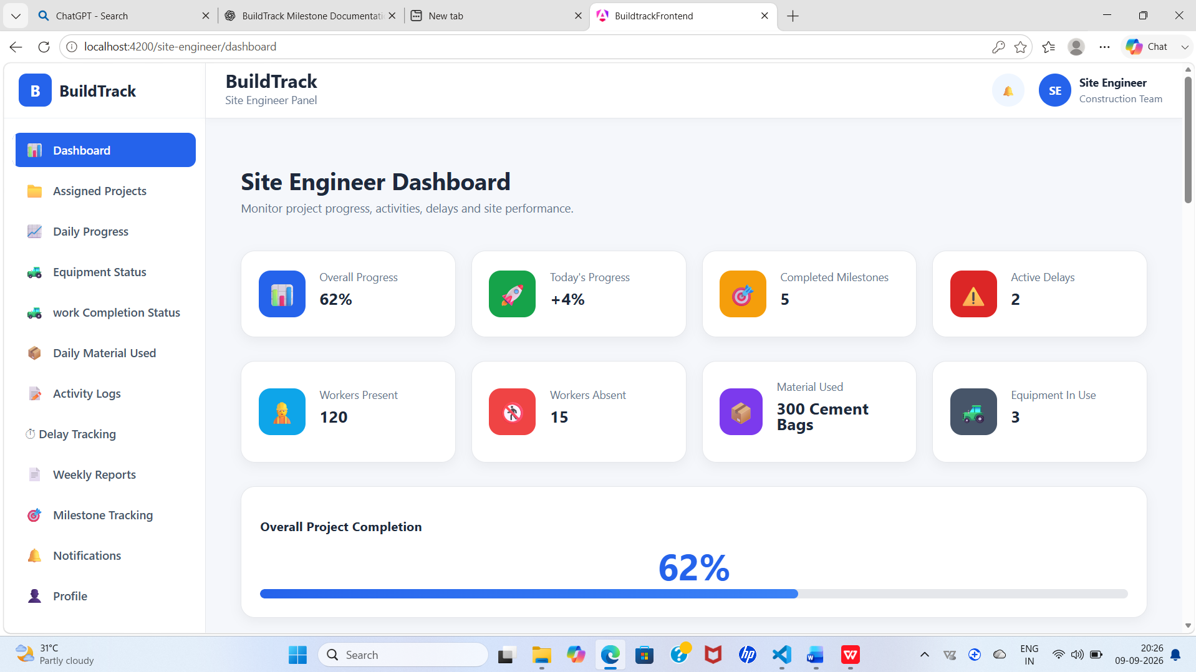
Figure 1: BuildTrack Site Engineer Dashboard
Capture the running Site Engineer Dashboard showing the progress, milestone, delay, workforce, material and equipment indicators.

4.3 Assigned Projects
The Assigned Projects page provides a dedicated area for the Site Engineer to review projects assigned to the role. Selecting a project leads to a project-details view.
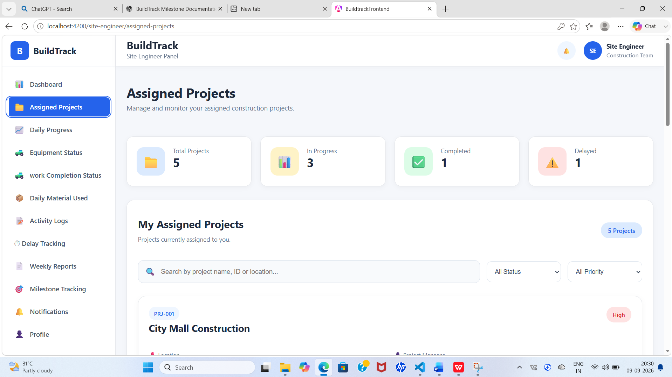
Figure 2: BuildTrack Site Engineer – Assigned Projects
Capture the Assigned Projects page and show the available project list or project cards.

4.4 Project Details
The Site Engineer Project Details page provides project-specific information for the selected assigned project. It gives the engineer a detailed context for monitoring site execution.
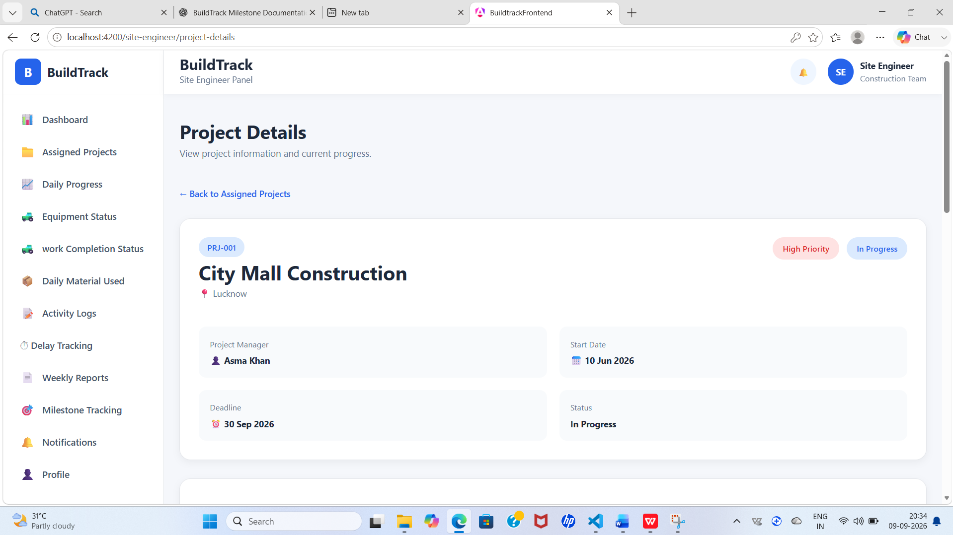
Figure 3: BuildTrack Site Engineer – Project Details
Capture the project detail page reached from the Site Engineer project area.

4.5 Daily Progress Report
The Daily Progress Report is used to record the construction work performed during a day. The current form contains Project Information, Report Date and Work Category fields. Work Details include Activity Performed and Work Completion. Contractor and Workforce information includes Contractor, Workers Present and Workers Absent. Equipment & Materials includes Equipment Used and Materials Consumed. Weather Conditions and a Safety & Quality section are also provided.
Section | Fields / Information
Project Information | Project Name, Report Date, Work Category
Work Details | Activity Performed, Work Completion (%)
Contractor & Workforce | Contractor, Workers Present, Workers Absent
Equipment & Materials | Equipment Used, Materials Consumed
Weather | Weather Conditions
Safety & Quality | Safety and quality-related report information
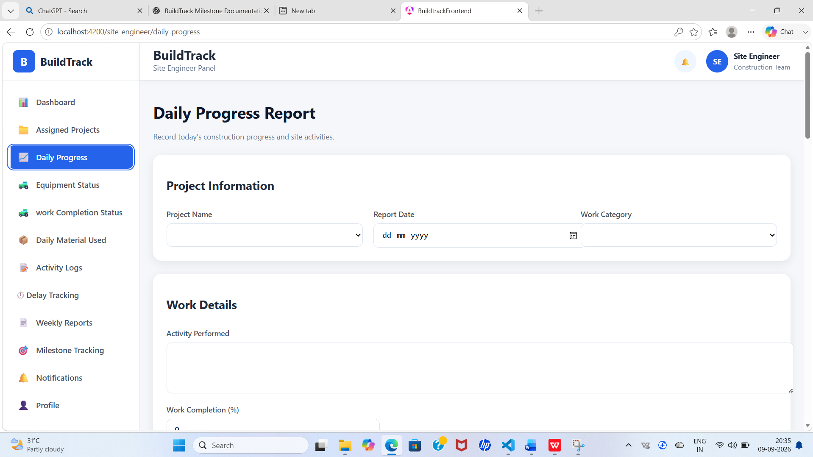

Figure 4: BuildTrack Daily Progress Report

Capture the daily progress form, preferably showing the main project, work, workforce and equipment/material sections.

4.6 Work Completion Status
The Work Completion Status page provides a consolidated view of project completion. It presents Overall Progress, Today’s Progress, Completed Milestones, Remaining Work, Overall Project Completion, Work Category Progress and Milestone Tracking.
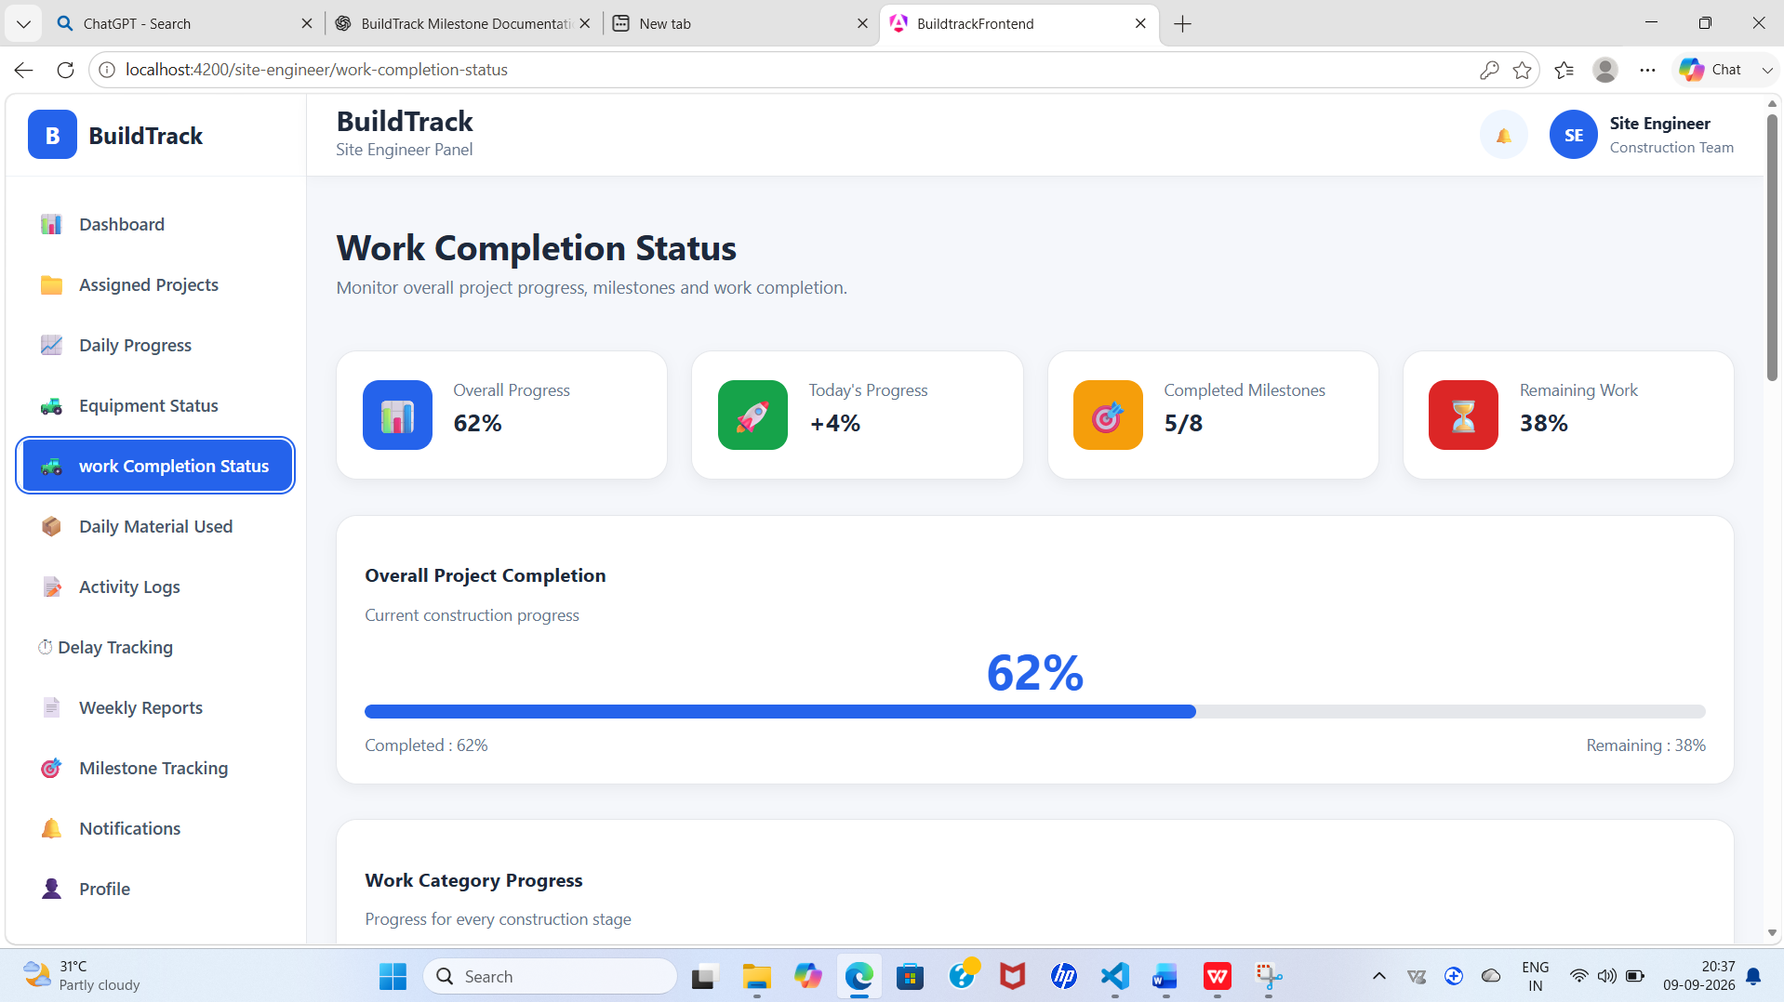
Figure 5: BuildTrack Work Completion Status
Capture the completion summary and milestone-tracking area.

4.7 Milestone Tracking
BuildTrack provides dedicated Site Engineer milestone and milestone-detail pages. These pages are used to review construction milestones and their completion information.
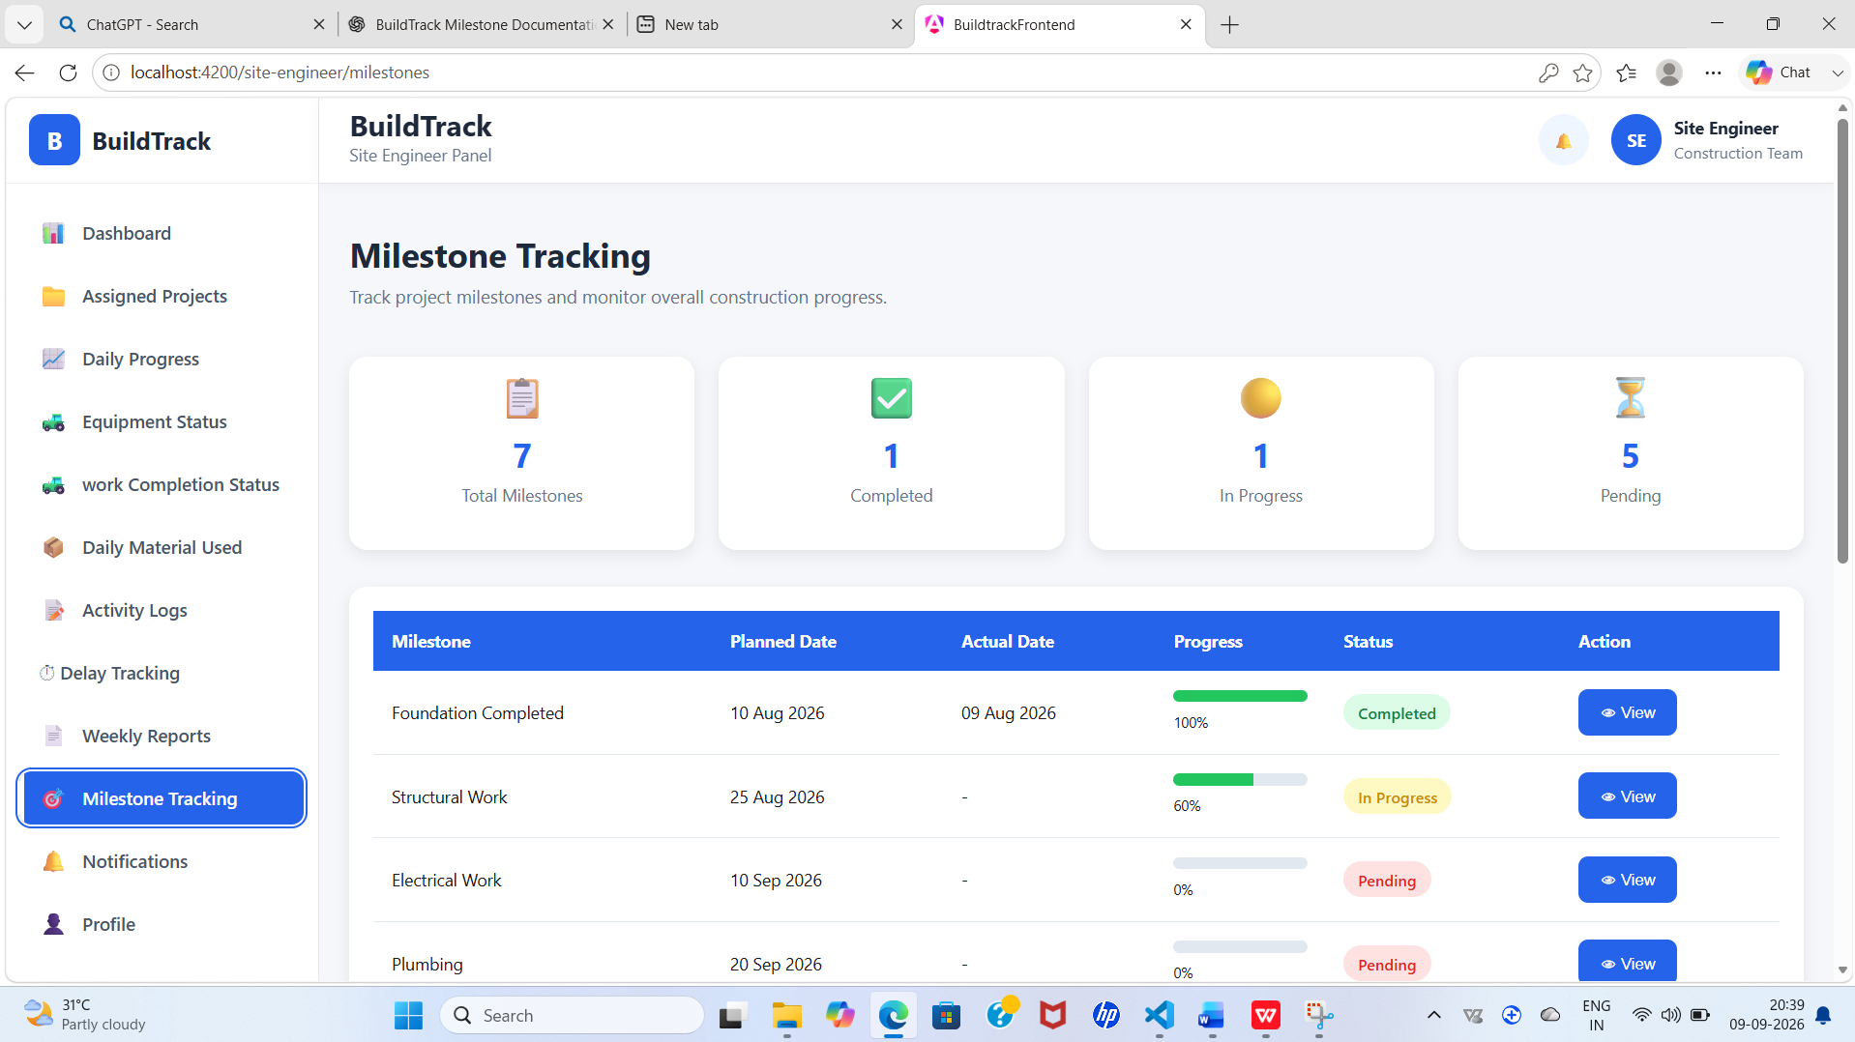
Figure 6: BuildTrack Site Engineer – Milestone Tracking
Capture the milestone list/timeline or milestone-detail screen.

4.8 Delay Tracking
The Delay Tracking page is designed to monitor project delays and their impact on execution. The interface provides Total Delays, Resolved, Pending and High Impact summaries. The delay table includes Date, Work Category, Delay Reason, Duration, Impact, Status and Action. An Add Delay interaction is also available.
The interface also presents common delay considerations such as weather-related delays, material delivery delays, labour shortage, machinery breakdown, financial constraints, design changes and government approval delays.

Figure 7: BuildTrack Delay Tracking

Capture the delay summary, delay table and Add Delay control.

4.9 Site Activity Logs
Site Activity Logs provide a structured record of important activities performed at the construction site. The page includes summary counts for Total Activities, Completed, In Progress and Pending. Search and filters are available for Project, Activity Type and Status. The table includes Date, Project, Time, Activity Type,.Description,Responsible Person, Status and Action 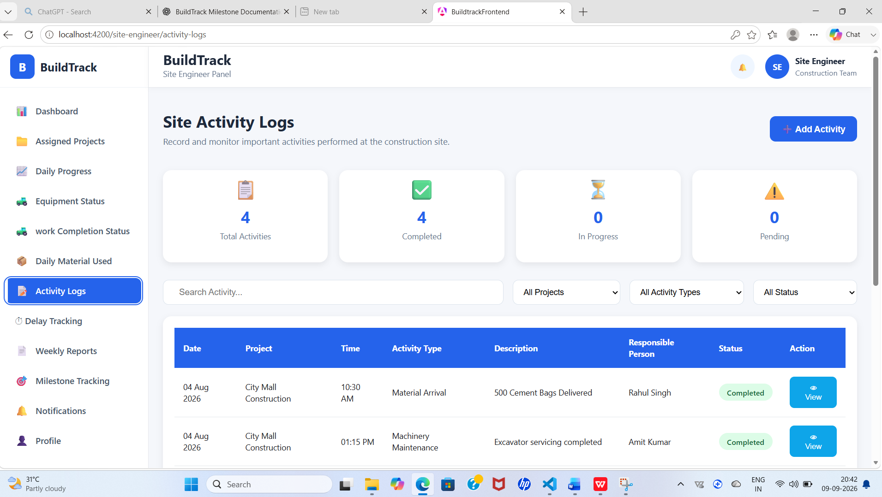
Figure 8: BuildTrack Site Activity Logs
Capture the activity search/filter area and the activity table.

4.10 Equipment Status
The Site Engineer area contains a dedicated Equipment Status page together with Add Equipment and Equipment Details pages. These screens provide the Site Engineer with access to equipment-related site information.
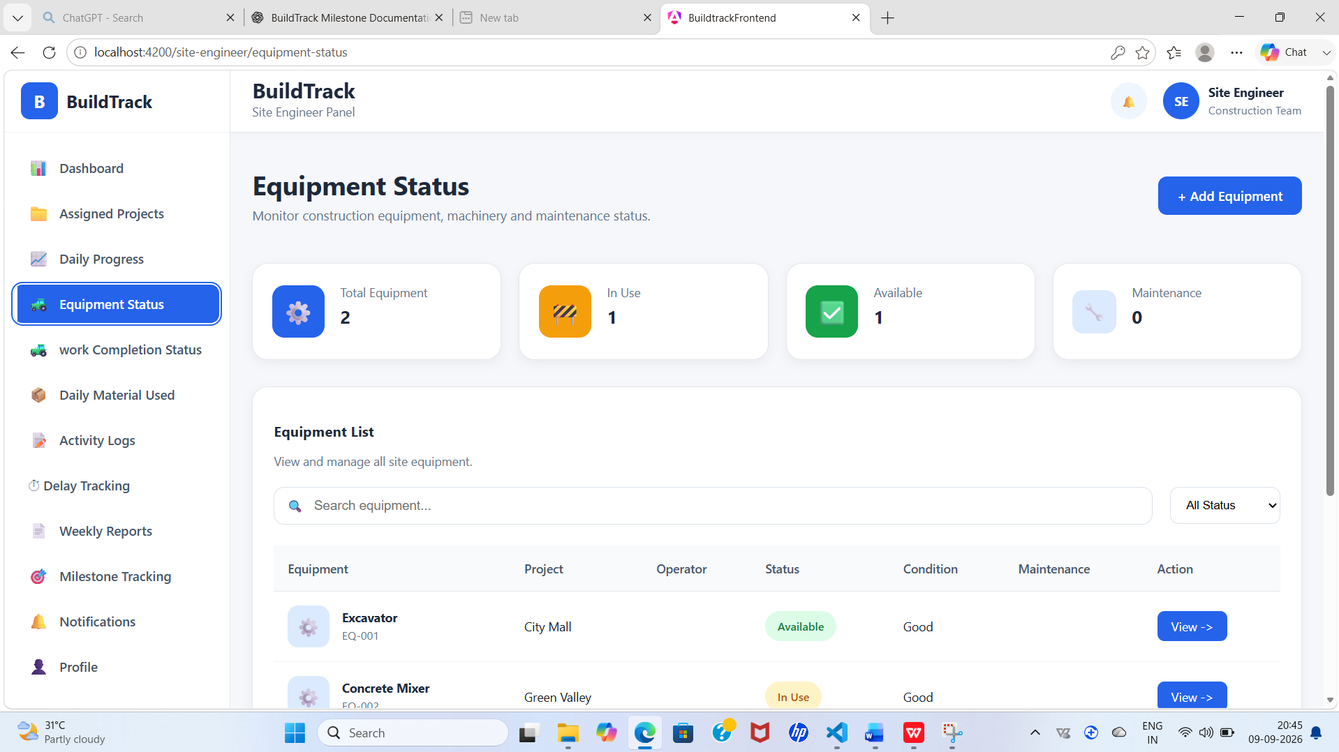
Figure 9: BuildTrack Site Engineer – Equipment Status
Capture the Equipment Status page.

4.11 Resources
The Site Engineer area contains Resources and Resource Details pages for accessing resource-related information required for site operations.
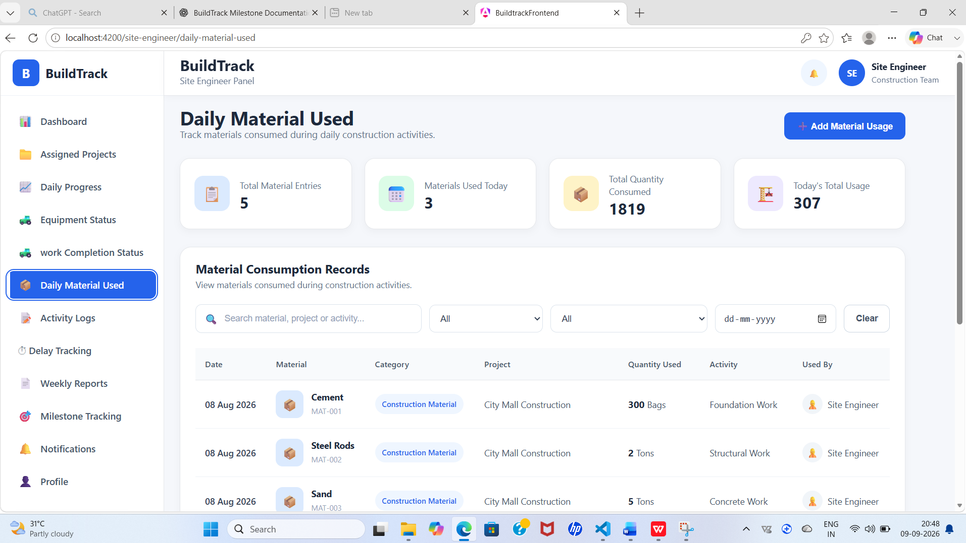
Figure 10: BuildTrack Site Engineer – Resources
Capture the Site Engineer Resources page or resource-detail page.

4.12 Weekly Reports
Dedicated Weekly Reports and Weekly Report Details pages are present in the Site Engineer workspace for periodic reporting and review.
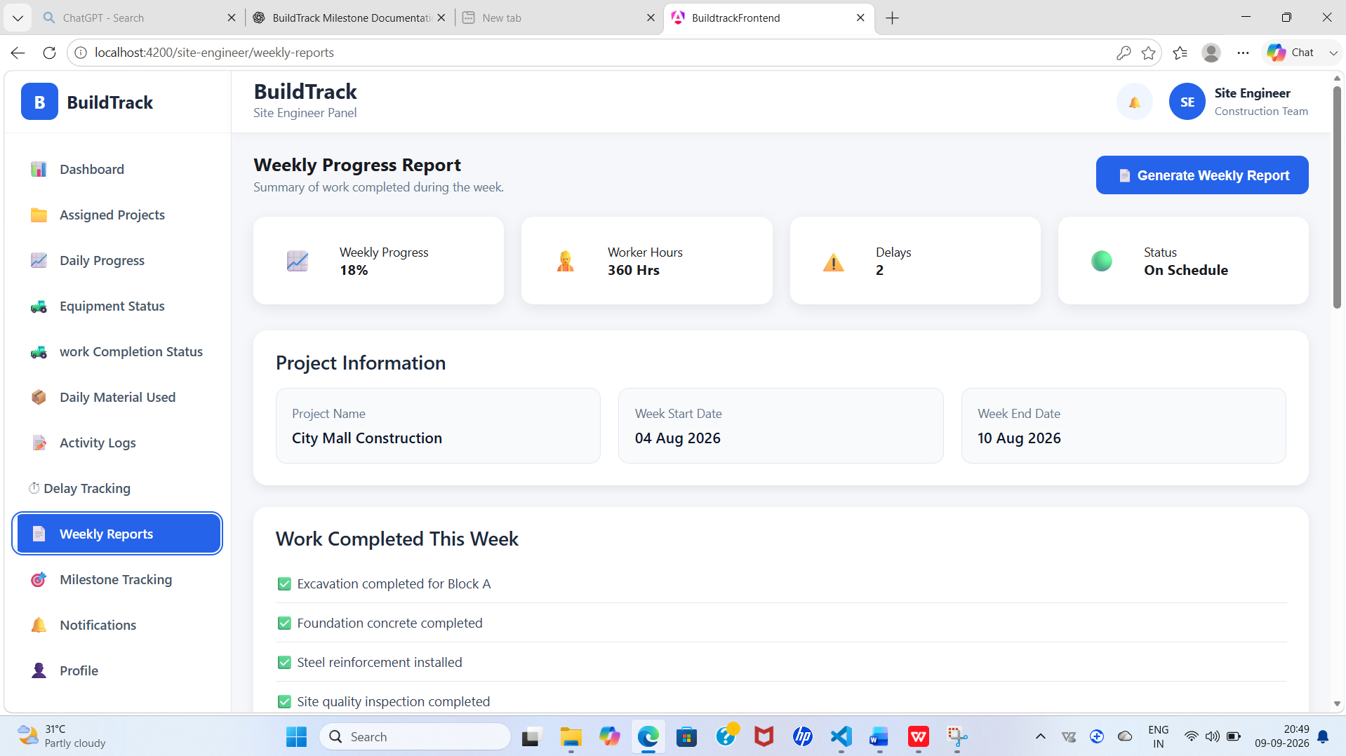
Figure 11: BuildTrack Site Engineer – Weekly Reports
Capture the Weekly Reports page or report-detail screen.

4.13 Notifications
A dedicated Notifications page is available within the Site Engineer workspace for accessing relevant project/site notification information.
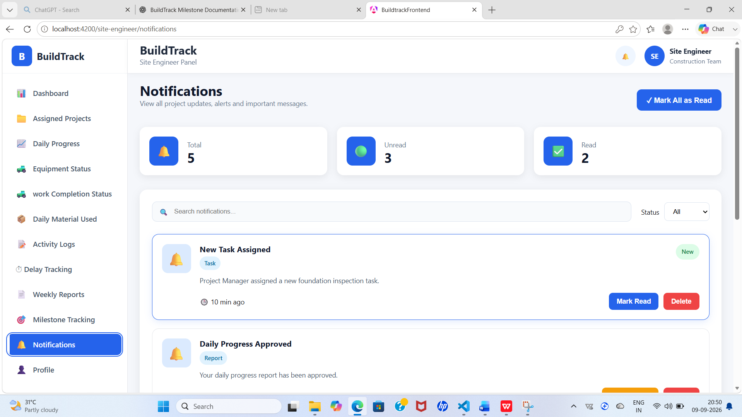
Figure 12: BuildTrack Site Engineer – Notifications
Capture the Site Engineer Notifications page.

4.14 Site Engineer Workflow
Step | User Action | System Response | Result
1 | Open Site Engineer Dashboard. | BuildTrack loads the site-monitoring dashboard. | Current site indicators are visible.
2 | Review project/site status. | Dashboard presents progress, milestones, delays, workforce, material and equipment indicators. | Engineer obtains a high-level site view.
3 | Open Assigned Projects and select a project. | Project details page is opened. | Engineer can review project-specific information.
4 | Enter Daily Progress Report information. | Angular form captures project, work, workforce, equipment/material and weather details. | Daily progress information is prepared.
5 | Open Work Completion / Milestones. | Completion and milestone information is displayed. | Engineer monitors work status.
6 | Add or review delays. | Delay page presents reason, duration, impact and status. | Construction delays can be monitored.
7 | Search or add site activities. | Activity filters and activity listing are displayed. | Site activity history can be reviewed.
8 | Review equipment/resources and reports. | Dedicated equipment, resource and weekly-report pages open. | Supporting site information is available.

4.15 Module Outcome
The Site Engineer module establishes a dedicated site-monitoring workspace covering project assignment, daily progress, work completion, milestones, delays, activity logs, equipment, resources, notifications and weekly reporting. It provides the frontend structure required for site-level construction monitoring.

5. Module 4 – Resource Management

5.1 Objective
The Resource Management module focuses on construction equipment and machinery. It provides interfaces for allocating equipment to projects, tracking machinery, measuring utilization, checking availability and monitoring maintenance.

5.2 Resource Management Dashboard
The Resource Management Dashboard provides a consolidated view of resource conditions. The page includes equipment-status information, resource-utilization information and resource-availability information. It also provides actions to Check Availability and Allocate Equipment.
Dashboard Area | Observed Information
Equipment Status | Total, Available, Allocated and Maintenance counts
Resource Utilization | Utilized percentage, operating hours, idle hours and monthly change
Resource Availability | Availability information for equipment
Actions | Check Availability and Allocate Equipment

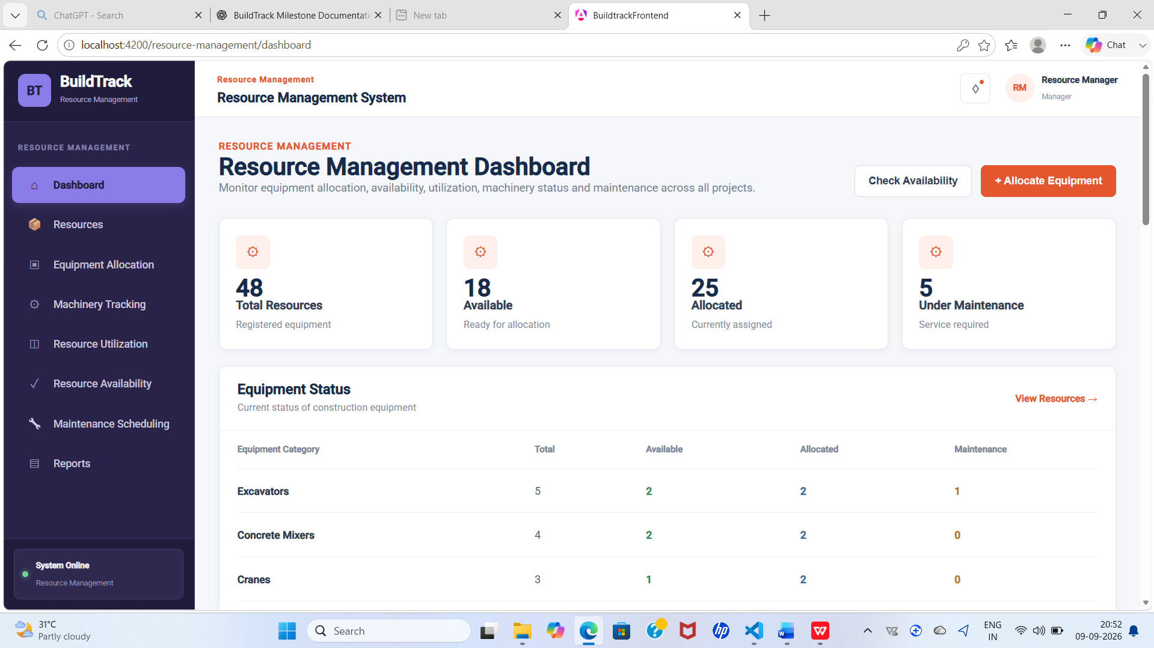
Figure 13: BuildTrack Resource Management Dashboard
Capture the dashboard showing resource statistics, equipment status, utilization and availability.

5.3 Equipment Allocation
Equipment Allocation provides a dedicated form for assigning construction equipment to projects. The form contains Project Name, Equipment Name, Equipment ID, Equipment Category, Quantity, Allocation Date, Expected Return Date and Responsible Person. Equipment ID and category are designed to be populated from the selected equipment. Equipment whose status is already Allocated is disabled from selection, helping reduce duplicate assignment.
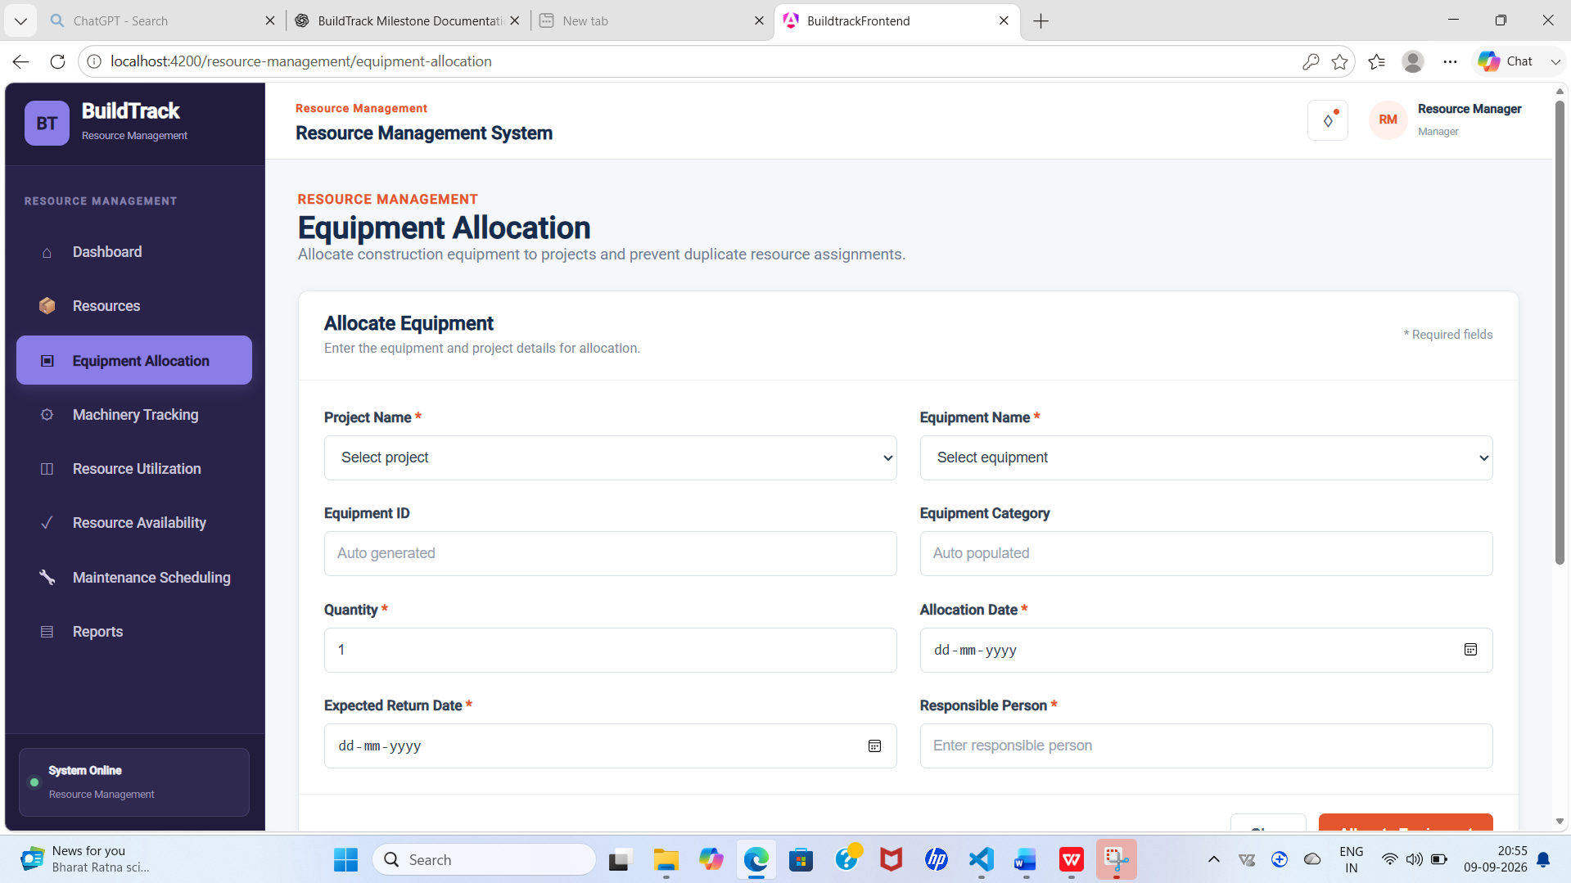
Figure 14: BuildTrack Equipment Allocation
Capture the allocation form with project, equipment, quantity, dates and responsible-person fields.

5.4 Machinery Tracking
Machinery Tracking monitors equipment location, project assignment and current status. The page provides summary cards for Total Machinery, Operating, Idle and Maintenance. Users can search by equipment, ID or project and filter by status. The table contains Equipment, Equipment ID, Category, Project, Location, Status, Operator and Last Updated.
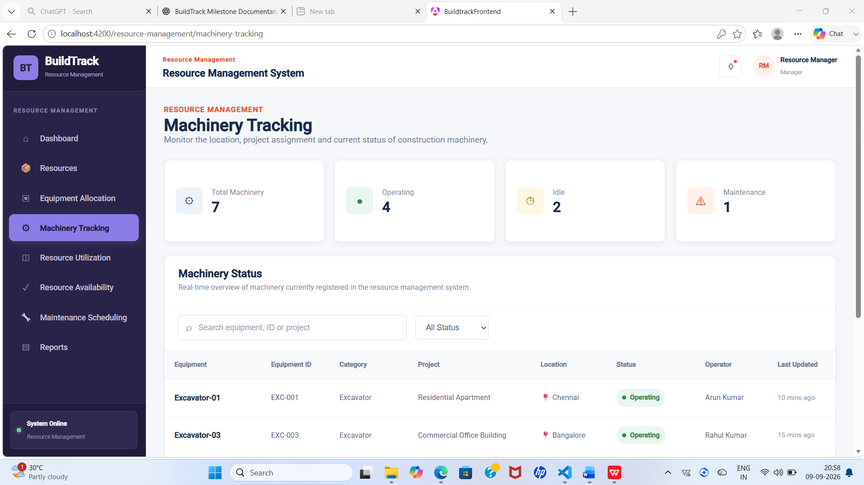
Figure 15: BuildTrack Machinery Tracking
Capture the machinery summary, search/filter controls and tracking table.

5.5 Resource Utilization
Resource Utilization measures equipment operating and idle time and presents utilization information. The page includes Average Utilization, Operating Hours, Idle Hours and Highly Utilized summaries. Project and Equipment Category filters are available. The table contains Equipment, Equipment ID, Category, Project, Available Hours, Operating Hours, Idle Hours and Utilization.
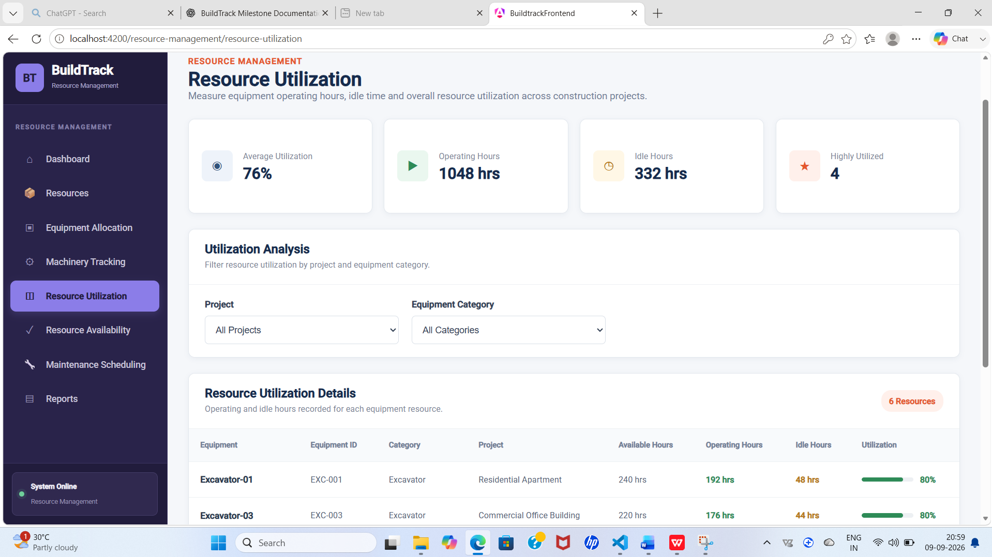
Figure 16: BuildTrack Resource Utilization
Capture the utilization summary and equipment utilization table.

5.6 Resource Availability
Resource Availability allows users to check current equipment availability before allocation. The page provides Available, Allocated, Under Maintenance and Out of Service summaries. Search and filters are provided for status and equipment category. The table includes Equipment, Equipment ID, Category, Current Location, Current Project, Available From and Status.
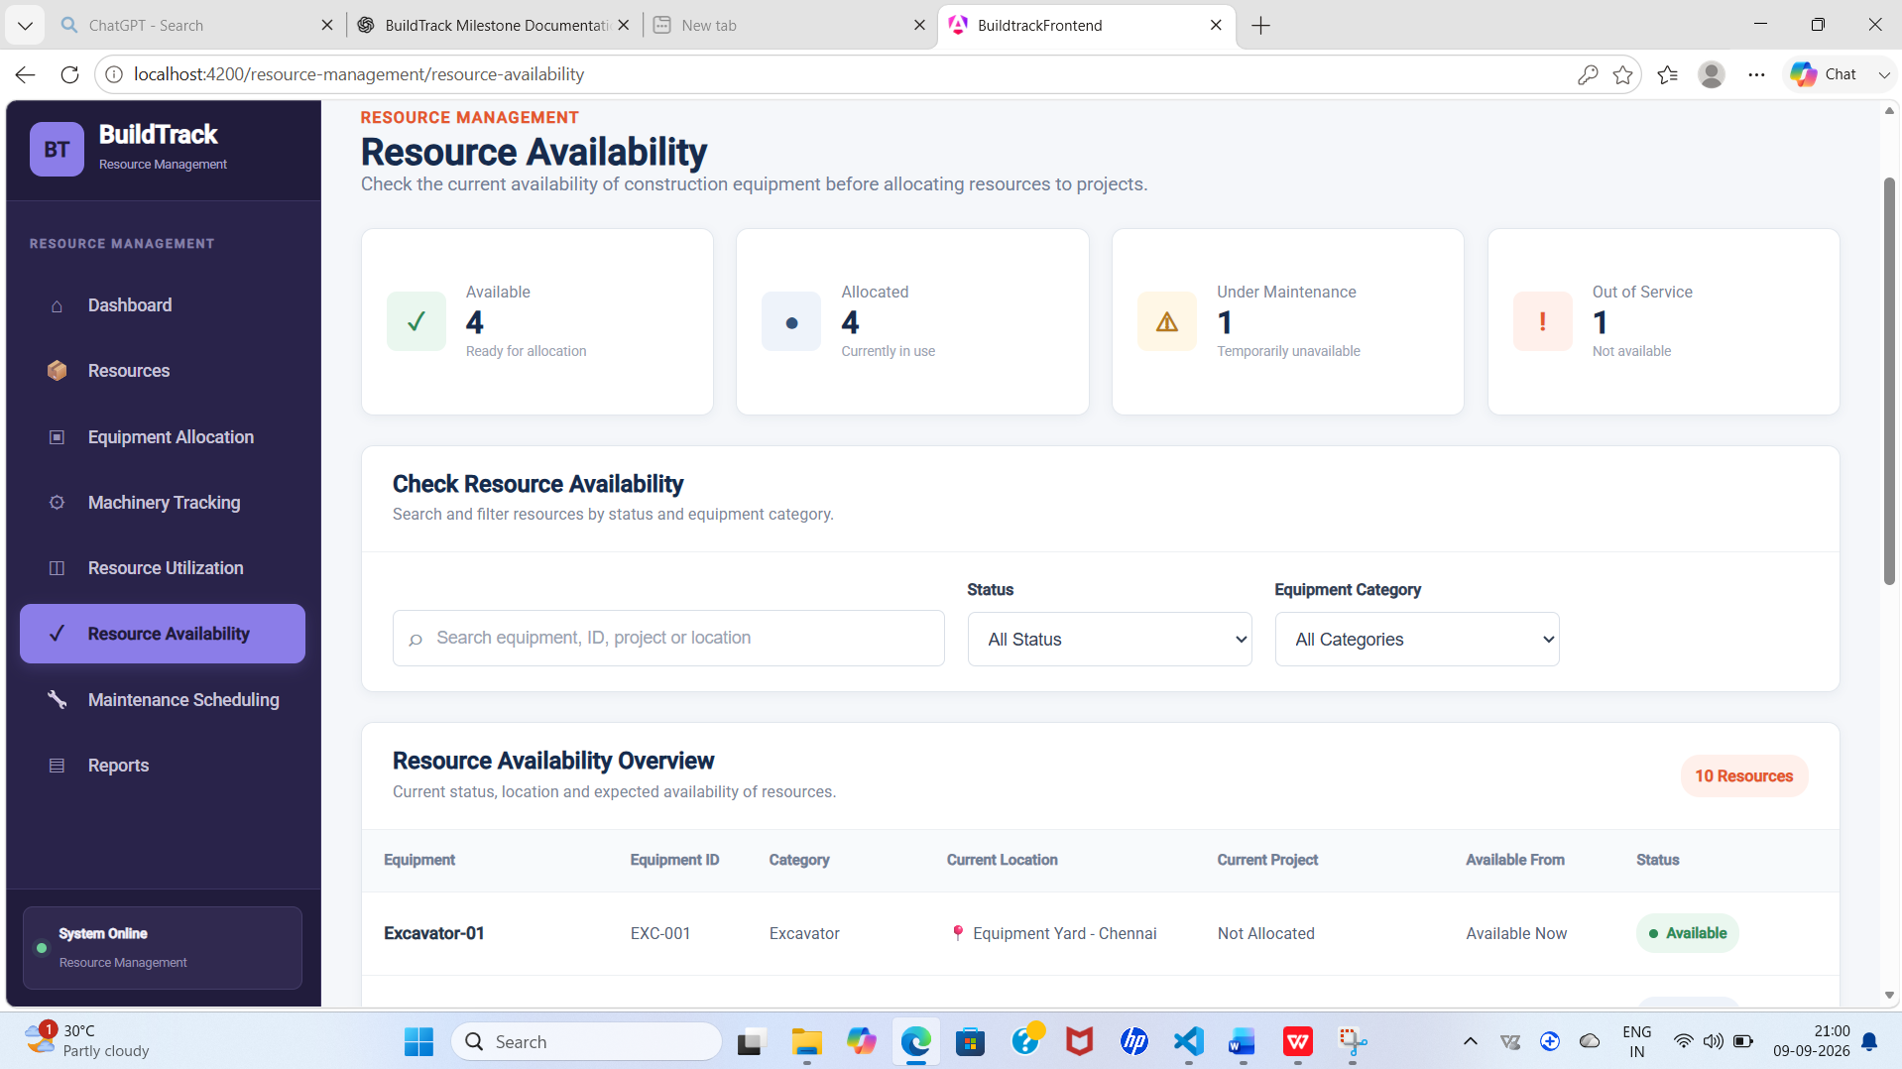

Figure 17: BuildTrack Resource Availability

Capture the availability summary, filters and equipment table.

5.7 Maintenance Scheduling
Maintenance Scheduling supports monitoring of construction-equipment maintenance. The page provides Upcoming, In Progress, Overdue and Completed summaries and displays Total Maintenance Cost. Search and filters are available for equipment, ID, service engineer, status and maintenance type. The table includes Equipment, Equipment ID, Last Maintenance, Next Maintenance, Maintenance Type, Service Engineer, Cost and Status.
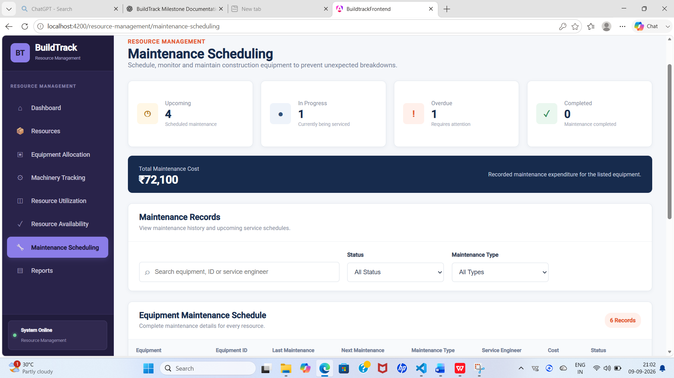
Figure 18: BuildTrack Maintenance Scheduling
Capture the maintenance summary, total cost and maintenance table.

5.8 Resource Reports
A dedicated Reports page is present within the Resource Management route structure for resource-related reporting.
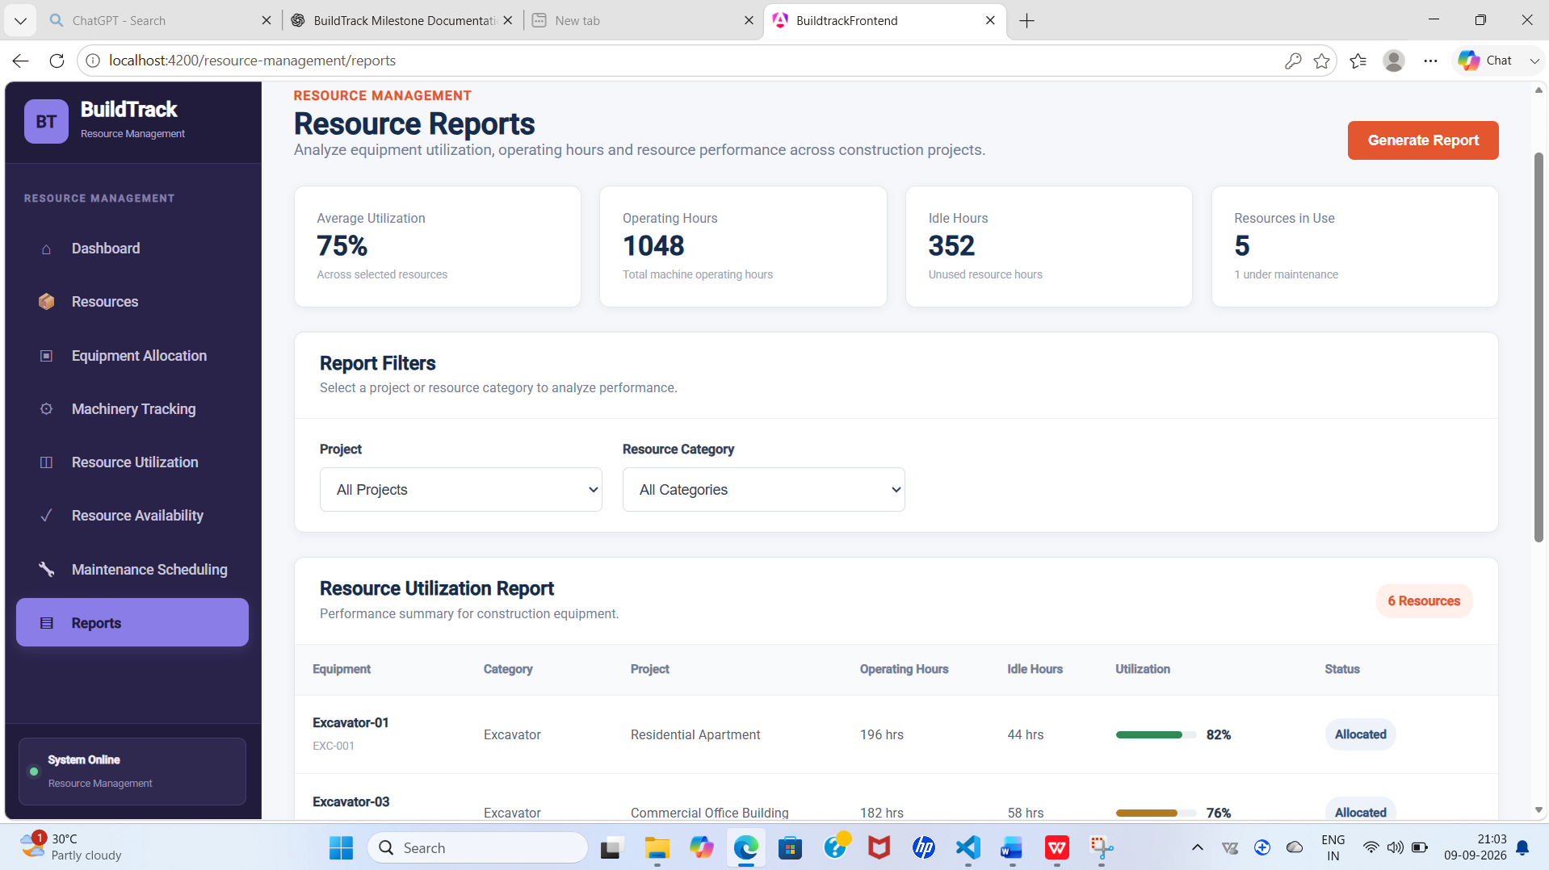
Figure 19: BuildTrack Resource Management Reports
Capture the Resource Management Reports page.

5.9 Resources
A dedicated Resources page is present within the Resource Management area for viewing resource information.
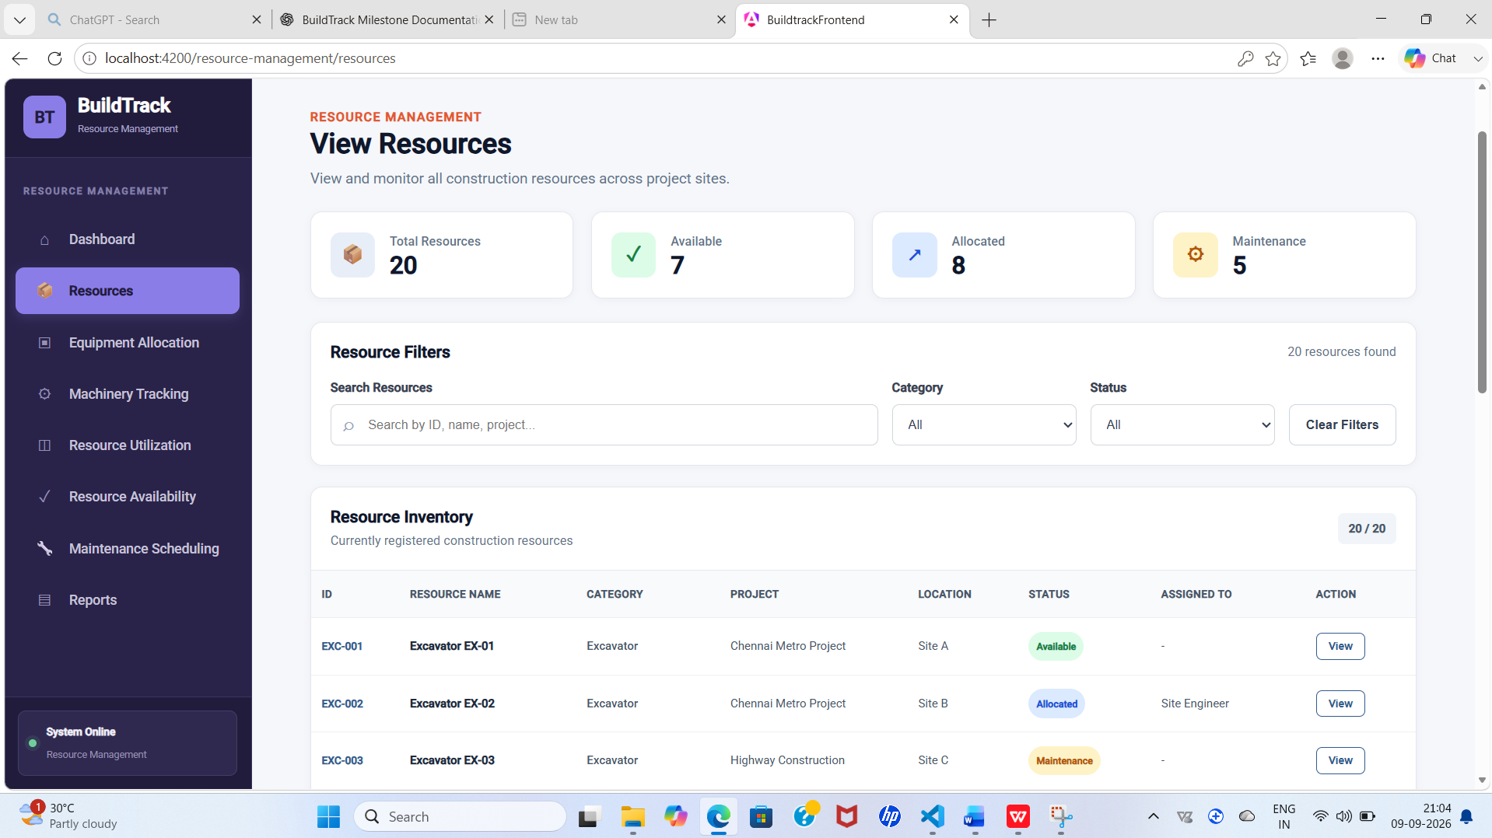
Figure 20: BuildTrack Resource Management – Resources
Capture the Resource Management Resources page.

5.10 Resource Management Workflow

Step | User Action | System Response | Result
1 | Open Resource Management Dashboard. | BuildTrack displays equipment status, utilization and availability information. | User obtains an overall resource view.
2 | Check Resource Availability. | Availability page presents status, location, project and available-from information. | User identifies suitable equipment.
3 | Open Equipment Allocation. | Allocation form is displayed. | User can enter allocation information.
4 | Select equipment and enter allocation details. | Equipment information is populated and already allocated equipment is restricted from selection. | Allocation can be prepared while reducing duplicate selection.
5 | Open Machinery Tracking. | Machinery table and status filters are displayed. | Current machinery information can be reviewed.
6 | Review Resource Utilization. | Operating, idle and utilization information is displayed. | Equipment usage can be evaluated.
7 | Review Maintenance Scheduling. | Maintenance status, dates, engineer and cost are displayed. | Maintenance requirements can be monitored.

5.11 Module Outcome
The Resource Management module provides dedicated frontend interfaces for equipment allocation, machinery tracking, resource utilization, resource availability and maintenance scheduling, supported by dashboard, reports and resource pages.

6. Role-wise Functionality
Role / User Area | Milestone 2 Capabilities Evidenced
Site Engineer | Access Site Engineer dashboard; review assigned projects and project details; prepare daily progress reports; monitor work completion and milestones; track delays; maintain site activity logs; review equipment/resources; access weekly reports, notifications and profile.
Resource Management User | Review resource dashboard; allocate equipment; track machinery; review utilization; check availability; monitor maintenance; access resource reports and resource information.
Other Roles | No additional Milestone 2 capability is claimed unless directly evidenced by the current project source.

7. End-to-End Milestone 2 Workflow
Input | Processing / Action | System View | Output
Project and site information | Site Engineer reviews assigned project and enters daily progress/activity information. | Site Engineer dashboard, reports, milestones, delays and activity logs. | Site progress and operational information available for review.
Work completion and milestone information | Engineer reviews completion and milestone status. | Work Completion Status and Milestone pages. | Current work and milestone status.
Delay information | Engineer records/reviews reason, duration, impact and status. | Delay Tracking page. | Delay information available for monitoring.
Equipment/resource information | User checks availability, allocates equipment and reviews machinery/utilization. | Resource Management dashboard and resource pages. | Equipment allocation and resource-status view.
Maintenance information | User reviews maintenance dates, type, engineer, cost and status. | Maintenance Scheduling page. | Maintenance requirements can be monitored.

8. Screenshots and Evidence Checklist
- Use screenshots from the running BuildTrack application rather than code-editor screenshots.
- Crop out unrelated desktop areas.
- Keep screenshot width and placement consistent throughout the document.
- Place each screenshot immediately after the relevant feature description, following the pattern used in Milestone 1.
- Use sequential figure numbering from Figure 1 onward.
- Capture the main dashboard, important forms, tables, filters and detail pages; avoid unnecessary duplicate screens.
- Update screenshots after the final UI changes so the evidence matches the submitted version.

9. Technical Implementation Summary
Area | Implementation Evidence
Frontend Framework | Angular 22 project structure with standalone components.
UI Components | Angular templates, forms, data binding, tables, filters, navigation and dashboard-style UI. Angular Material is present in the project; individual Milestone 2 pages should be described according to the actual rendered UI.
Routing | Dedicated Angular routes exist for Site Engineer and Resource Management pages.
Site Engineer Pages | Dashboard, activity logs, daily material used, activity details, milestones, milestone details, delay tracking, work completion, delay details, assigned projects, project details, daily progress, daily report details, equipment status, add equipment, equipment details, notifications, profile, resources, resource details, weekly reports and weekly report details.
Resource Management Pages | Dashboard, equipment allocation, machinery tracking, resource utilization, resource availability, maintenance scheduling, reports and resources.
Backend Framework | Python FastAPI application with multiple routers.
Database Layer | SQLAlchemy engine/session configuration and ORM/database layer.
Authorization | authGuard and roleGuard are defined; protected Site Engineer routes use authentication and role guards.
Integration Note | Frontend pages should not be described as live database-backed functionality unless the corresponding API/persistence is demonstrated.

10. Limitations / Pending Work
- Some Milestone 2 screens present frontend UI and data structures; the exact level of backend persistence should be verified feature by feature.
- The existence of a route or screen alone is not treated as proof of complete API/database integration.
- The final documentation should use screenshots from the latest running BuildTrack version.
- Any remaining integration, validation or persistence work should be recorded as pending rather than presented as fully operational.

11. Milestone 2 Completion Summary
Item | Status / Evidence
Milestone | Milestone 2
Modules Covered | Module 3 – Site Engineer; Module 4 – Resource Management
Site Engineer | Dedicated dashboard, project views, daily progress, work completion, milestones, delay tracking, activity logs, equipment/resources, weekly reports, notifications and profile.
Resource Management | Dashboard, equipment allocation, machinery tracking, resource utilization, resource availability, maintenance scheduling, reports and resources.
Screenshots | 20 recommended screenshot positions covering the principal pages and workflows.
Technical Foundation | Angular frontend, FastAPI backend, SQLAlchemy/database layer and route guards are evidenced in the project.
Overall Status | Milestone 2 functionality is represented through dedicated frontend pages and workflows; backend persistence should be verified for each feature before claiming complete integration.

12. Conclusion
Milestone 2 extends BuildTrack from the project-management foundation into site-level construction monitoring and resource management. The Site Engineer module provides a structured workspace for daily progress, work completion, milestones, delays, activity logs, project information and supporting site resources. The Resource Management module provides equipment allocation, machinery tracking, utilization, availability and maintenance-monitoring interfaces. The documented limitations preserve a clear distinction between implemented frontend functionality and backend integration that still requires verification.

